Game manual (version 1.100)
Contents

Campaign 3
Starting a campaign game 3
Campaign screen overview 3
First steps in campaign 4
Provincial buildings 6
Cities 7
Division hierarchy 8
Divisions in the field 9
Annexion of Cities 10
Fleets 11
Commanders 12
Finances 12
Statistics 13
Natives 13
Research 14
Policies 14
Diplomacy 15
Seasons 16
Battles 16
Historical battles 16
Campaign battles 16
Selecting and moving units 17
Regiment information 17
Fog of war 20
Viewports 20
Reinforcements 20
End of battles 20
Battle results 21
Options menu 22

Campaign

Starting a campaign game

Click on >campaign< in main menu to start one of the 20 campaign scenarios. Playable are the 5 main warring nations (Britain, France, Austria, Prussia and Russia) out of a total of 13 countries. Click on one of the five flags on top to change the nation. Every nation has its individual advantages based on historic strengths.
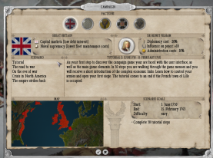On the left side you can choose the scenario. Beside long term campaigns like "The road to war" or "On the eve of war" country specific scenarios can be played, e.g. "The miracle of House Brandenburg". A 30 step tutorial can be played as Britain, therefore just choose the first British scenario “Tutorial”.
In every scenario the player has to fulfill certain goals which can be seen on the bottom. The scenario ends if all goals are met and the time expired. Afterwards you can decide to continue the finished campaign if you like.

Campaign screen overview
10
9
7
8
6
20
19
18
17
16
15
14
13
12
11
5
4
3
2
1
- Overview of production and demand
- Overview of owned provincial buildings
- Game menu
- Army overview
- Fleet overview
- Current date
- Game speed
- Treasury of your nation
- Quarterly earnings (earnings vs. costs)
- Tooltips or Tutorial info on/off
- Short info: politics menu (click on symbol to choose politics)
- Short info: diplomacy menu (shows relations to other nations)
- Short info: technology menu (click on symbol to open research menu)
- Building menu (for provincial buildings which can be directly placed on the map)
- Financial Statement (open for overview and options like war loans and coin debasement)
- Current goal status and nation overview
- Commanders overview (open to promote officers)
- Nation comparison (statistics and information how your nation does compared to others)

First steps in campaign

Build mines or farms on the campaign map near resource fields to harvest special resources.
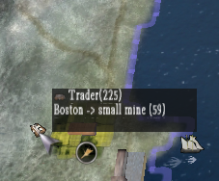Traders in the local province transport resources and goods from companies to local markets, other cities or other companies. As the traders are state run, their profit is added to your income sheet, shown in the city menu. The higher the profit margin of the product compared to the market price, the higher is the probability of delivery. The more products are offered the lower the price is quoted.
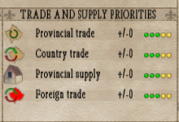In the city menu you can manually adjust the priority for special tasks in each province. There you can set low or high priorities for corporate supply and goods pickup within this province, national trade from this province to neighbored (owned) provinces or (owned) oversea provinces and international trade with (foreign) neighbored provinces or (foreign) oversea provinces.
To produce higher valued goods a product chain has to be set up: e.g. plant wheat in your farms which is transported to a mill, the produced flour is brought to a craft producer where it is transformed to bread which is used for supplying your armies, fleets and cities. If you move your mouse over the goods overview menu (on bottom of city or corporate menus) you can watch details about each product, e.g. the necessary pre-goods or provincial production and demand.
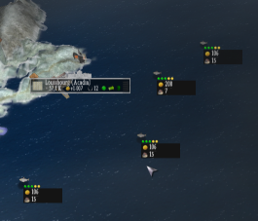Sea trading fields include fish, spice (southern Atlantic) and sugar (western Atlantic). Sea trading fields are slowly increasing their stock while the price drops, they can be harvested by your trade fleets. Traders and fleets always will focus on the highest profit margin in relation to the transport distance although you can set the priority of each good, trading field and native goods. For sea trading fields you can set the priority of each field directly on the campaign map. Use the right mouse cursor to set the priority of all seafields of this type.
To use import or export markets just negotiate trade treaties with other nations. You can do this in the diplomacy menu for each country.
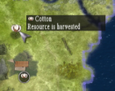Map resources are shown on the campaign map and can be used only once: use a hunting lodge to harvest furs, farms to harvest cotton, tobacco and sugar and mines to harvest loam, iron ore and coal. Be sure to place the provincial building close to the resource so that it is highlighted.

Goods & Product chains

To produce higher valued goods you have to set up a complete product chain. Below, all of the possible product chains of the game are shown:

Loam can be resourced by mines and can be produced to bricks by handicraft buildings. Bricks are important to construct buildings
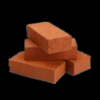
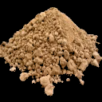
Bricks
Loam
Saltpeper can be produced in your farms, combined with coal it is produced to black powder in your handicraft buildings. Together with bullets it is used for ammunition.
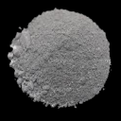
Black powder
Coal & Saltpeper
Coal and iron ore can be resourced by your mines. You need both resources to produce iron in your handicraft buildings. Iron is a basic product for higher level buildings and weapons.
Iron
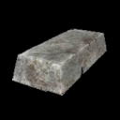
Coal & Iron ore
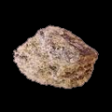
Wheat can be grown in your farms during summer season and is then brought to a mill to produce flour. Flour can be produced to bread in handicraft buildings.
Bread

Flour
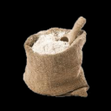
Wheat
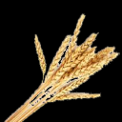

Timber can be felled in lodging buildings. Take care to place the lodging camp next to a forest to grant resource supply. Timber is brought to local building sites and perhaps the most important resource to construct buildings
Timber

Provincial buildings

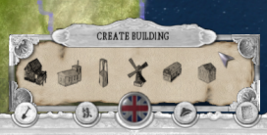Provincial buildings can be built on your own terrain. Decide between lumber mills (have to be placed near forest), farms (keep an eye on potential map resources), mines (have to be placed near map resources), hunting lodges (have to be placed near fur map resources) and craft producers (should be built near cities to reduce the transport duration).
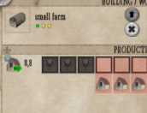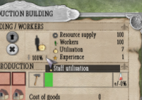You can adjust the utilization through increasing the staff. Depending on the jobless rate in the local province staff can be build up very fast or very slow. The longer your staff produces the same product the more experienced they will become and the better the production output will be.
Choose the production by clicking on the first storage places, the needed pre-goods are automatically set and delivered (depending on the provincial supply priority which can be set in the city menu).
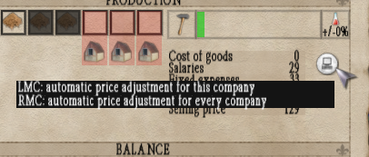Change the price of the product to increase the pickup priority by a local trader: Traders have limited transport capacity and will pick up only goods with high profits. If you increase the selling price of a product in the company menu then the probability of sale to a merchant is reduced. Keep an eye on the market prices where the trader can sell the product in the local province. If you wish to auto adjust the selling price just LMC on the relevant button next to the product calculation, RMC to auto adjust the prices of all of your companies.
Take into account to produce building goods like timber, bricks and possibly iron first as every building needs building materials. Second try to improve your food production and third try to build up your weapons industry.
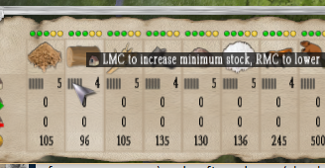If you are short on special resources try to set a minimum stock quantity in the province. You can do that by adjusting the bars shown next to the stock in the goods overview menu (when opening city or company menus shown on the bottom).
Smaller nations may not have access to every resource that is why you should negotiate trade treaties with foreign nations you should try to occupy foreign provinces before this kind of resource is exhausted.

Cities

Cities are the center of the provincial economies. There, goods are sold and bought by local traders. To set priority of supplies just use the priority bars in the priority menu. Supply and delivery is a product of profit margins, distance and defined supply priority. Move your mouse over the products shown below to gain further information about production, demand, prices and needed pre-goods.
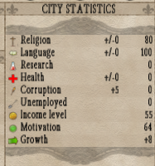You have to manage the mood of your population. Increasing tax rates increases unhappiness, as well as high corruption, high jobless rates, spreaded religion and language, low health and low income. To improve these features you can construct city buildings, build provincial buildings (reduces jobless rate), add garrisons (reduces unhappiness) or increase product offer to lower prices (increases people's income). Luxury goods like furs, sugar and spice give a special boost to happiness. The happier the population the higher the growth of the town which then increases your available recruits.
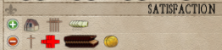Every factor has impact on other factors. E. g. if people's income is very low they are spending less on goods, prices are falling, corporates earn less and last but not least they are forced to enlist into the army.
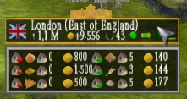Every city represents diplomacy/victory points depending on the size and earnings, which can be used for offerings in peace treaties or diplomatic actions. The capital is marked golden on the campaign map and has a higher weighting on victory points.
If you move the mouse cursor over the city short description a menu opens with the most demanded and offered goods. On the left side (red arrow) the demand is stated, on the right side (green arrow) the offer. Next to the product symbol the current stock and price is shown. The weighting of the ranking is done by a mix of the available stock and production and demand of the province.
Units can be recruited in cities if at least field camps are constructed and the necessary recruits are available. Each unit needs resources for setup, depending on the type of arms and an officer (if a brigade or division is newly formed you will need 3 officers: a colonel for a regiment, a general for a brigade and a field marshal for a division). To increase the numbers of recruits you can order forced recruitments which increases the unhappiness or hire mercenaries in foreign nearby provinces which has a negative diplomatic impact.
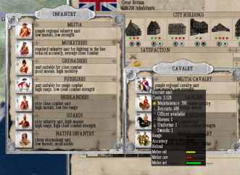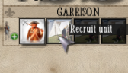Just click on the garrison bars to open the recruiting menu. Some units can only be recruited in limited numbers, some in special provinces. Native units can only be recruited in provinces where allied natives are situated. The maximum recruitable native units depend on the strength of the clan, they cost nothing except firearms but are only usable for skirmish actions in battle. If recruiting time has passed the unit is available in the garrison place in the local city. There it can be transfered to nearby divisions by drag and drop in the division hierarchy.
To create a new division simply drag and drop a garrisoned regiment on the soldier symbol at the left. By clicking on the division hierarchy button the regiments can be added to or removed from a brigade or division. The regiment can there be named or its weapon can be replaced.
Every weapon has its special impact on movability, fire range, fire accuracy and fire strength. Weapons can only be replaced in city range when this kind of weapon is on stock.

Division hierarchy

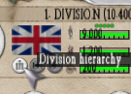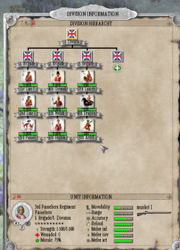You can take a look on the division hierarchy if you press the hierarchy button in the army selection menu. Every division is formed of 1 – 5 brigades which consists of 1-5 regiments.
You can drag and drop each unit to reallocate. Even whole brigades can be shifted (e.g. to divisions close by). If you click at the unit symbol you can see additional information about the regiment or brigade.
Weapons add to the movability, strength, range or accuracy of the selected unit. Weapons can be replaced by moving the division close to a city and clicking on the weapon symbol. Every new weapon needs a weapon resource.
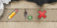In the hierarchy menu you can also rename each unit by clicking on the pencil, form a new division by dragging a regiment to the soldier plus symbol or disband whole regiments or divisions by clicking on the x symbol.

Divisions in the field

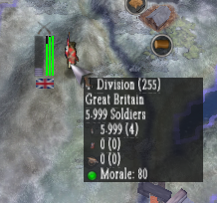After choosing a division on the campaign map it can be moved by RMC. Fastmarch can be ordered at the cost of morale. Order maneuvers to increase the experience of your troops at the cost of morale and ammo. Every division has to be supplied with food, ammo and soldiers through the local supply depot in the city menu. Supply trains can supply the local or nearby provinces.
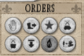Supply lines can be cut by enemy division (if the order <intercept trains> is activated), so cover your supply lines if advancing on enemy territory. To reduce supply usage in enemy territory you can order plunder and looting which causes damage to the local buildings, increases unhappiness in the local province and pushes a lot of new willing recruits to the enemy ranks.
In the colonies you may only move smaller armies as the supply capacity is very limited. If you wish to transport armies over the sea just right click on the target destination and the army is automatically shipped in if a fleet has enough capacity. Alternatively you can click on the ship in order button.
After fighting a battle your divisions may have casualties to replace which are slowly added via supply trains. Some wounded may come back to action, depending on the local provincial health situation.
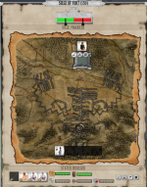If you move your divisions to an enemy city or fort a siege starts, but only if a city defense building with stationed garrison exists or the fort is occupied by enemy troops.
To win a siege you have to crack the defender's morale by starting all out attacks or using demoralizing artillery and grenade fire. A siege can also be won by starving out the enemy which makes only sense if the food stocks have already been low.
Winning a siege by an all-out attack will only succeed if you are close enough to the fort so that the defense artillery suffers less casualties. You can build trenches and artillery positions to improve your chances. Allocate available regiments to building crews, trenches or artillery positions.
At the larger distance your artillery will only fire rounds, at close distance it may fire grenades which suffers severe damage. The defender may focus its fire on the pioneers which slows the building process, on the attacker's artillery which suppresses artillery fire and on the attacker's infantry which suffers casualties. The longer the artillery fire lasts the higher is the damage at the city buildings.
If your troops are strong enough you may offer the besieged enemy to withdraw his troops and hand over the city or fort.
To transport army divisions to oversea territories just click on the order <embark> button in the order menu of the division. A fleet with enough capacity automatically meets with the division at a near coast line. Afterwards you can choose the fleet and RMC on the target land destination to debark. Alternatively you can choose your division and directly RMC on the target land oversea destination.
If an army is located on enemy terrain and the relative strength or moral falls below a certain level it is routed and moved to the nearest friendly city to rally.

Annexion of Cities

If you are at war with another faction you may conquer enemy cities. Therefore move your armies to the enemy city. If garrisons are positioned a siege will commence, if not the city is occupied without resistance.
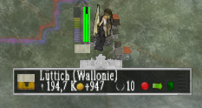If an enemy city is occupied half of the stated victory points of that city are added in favor of your balance but the formal owner still claims possession of it. Occupied but non-owned cities show up a splitted flag (on the top the occupier, on the bottom the nation that claims ownership).
In this situation the corruption is permanently rising, depending on the distance to the own and enemy capital. If you occupy a province far away from the enemy capital but close to yours the population might not be that unhappy to join your nation. Another negative fact is that you cannot recruit units in this province until it is fully owned by you.
To claim full ownership of occupied cities just open the city menu and press the button <Claim ownership>. This can only be done if the two nations already have signed a peace treaty and enough diplomacy points are left to claim ownership.
Remember that you have to be in full ownership of a province so that it counts for the victory conditions.

Fleets
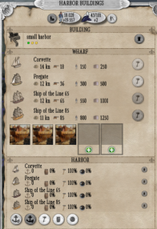
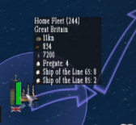Fleets are used to protect the own naval trading routes or to cut enemy trading and supply routes. Ships can be built in local harbors and can then be assigned to new or existing fleets if the fleet is located near the harbor. Adding ships to fleets need recruits, supply and ammo. If you like to create a new fleet just LMC at the <new fleet> button. An officer needs to be assigned, the higher his rank the more ships he may command.
Move your fleet by RMC on the campaign map, multiple waypoints may be set by RMC further. To cancel all waypoints just press the <stop> button. If the <patrol> button is activated the fleet repeats all further set waypoints.
If the ships supply stocks are exhausted the fleet automatically returns to the nearest harbor with the highest resources in stock. A ship battle starts if two fleets are approaching within their action radius and is solved automatically depending on the ship types, technologies and doctrines.
To intercept enemy fleets or trade fleets simply activate the “intercept” button. If two enemy fleets meet (within range radius) a naval battle starts. Naval battles are fought realtime but calculated automatically. Victory or defeat is determined by the number and types of included ships, quality of the commanders and researched naval doctrines. If the condition of your fleet falls below a certain level or the ammunition is exhausted the battle is lost. You can track the battle by moving the mouse over the side information on the left screen side. Trading fleets cannot defend themselves and are conquered immediately. The transported goods of captured trading fleets are taken over to the attacking fleet and are automatically sold at the next harbor stop. The captured trading fleet is replaced automatically in the home harbor.
Next to the commander you can see additional information of the fleet containing ships, speed, cannons, sailors, loading capacity (stated in soldiers), condition, supply and ammo status.

Commanders

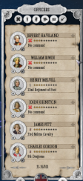Officers are necessary for setting up regiments (colonel), brigades (general), divisions (field marshal) and fleets (admiral). Every commander gains experience through maneuvers, policies or battle honors. You can manage your commanders by clicking on the commander overview at the bottom of the screen.
Commanders are recruited in officer academies in local cities. If they are allocated the first time they adopt the branch of arms of the unit they are allocated to. If you want to change the branch of arms by allocating the commander to a new unit (e.g. from navy to infantry) the commander loses all or parts of his experience. The higher the experience of the commander, the lower are the deserting rates and the more rally commands are available in battle. Experienced commanders also execute orders faster and show less irrational behavior.
If you wish to switch commanders simply click on a unit (divisions and fleets on the map, regiments and brigades in army hierarchy menu) and click on the switch button situated next to the commander picture.
To promote commanders to reach higher hierarchy levels they have to have enough experience. Once promoted they can be leader of higher unit levels but lose experience.

Finances

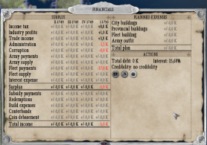In the finance menu all revenues and costs are shown for the current and the last quarters. Coin debasements can be made to add to your treasury at the cost of unhappiness and higher prices in your nation, which again leads to lower people's income and lower tax revenues.
Issuing war loans may help in short term but they are due in some years and you will have to pay interest. The better your financial situation and the lower the issued debt, the higher your rating will be which has therefore a positive effect on the next coupons you have to pay. If you are not able to redeem a war loan you may decide to declare bankruptcy which stresses your diplomatic relations to other countries and prevents issuing new loans for a longer time period.
If your finances go negative you cannot pay your armies which leads to demotivation and higher desertion rates.

Statistics

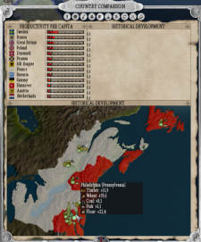A huge set of statistic menus is available to help keeping the overview of your nation. In the country comparison you can take a look at how your nation does compared to your opponents. You can access this menu by clicking on the specific button on the bottom of the campaign menu.
On top of the screen you can find the overview menus: In the company menu you have a brief overview of your companies, your production and your industry earnings. The goods statistics shows all the produced and demanded goods of your nation, the army and fleet statistic shows your units and military data.

Natives

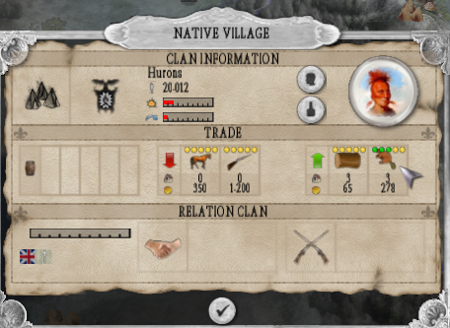Native clans are scattered all over the map ranging from clans like Natchez in Louisiana to the Sami in Sweden. The population of the individual clans is gradually mounting which adds to the strength of the clan.
You can also trade goods with clans to improve relations. Traded weapons increase the strength of the clan, traded horses the activity range.
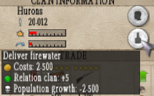If a clan is allied with a European nation this nation can set an enemy of the clan. Then, nearby supply routes are attacked depending on the range and strength of the clan. Second the allied European nation can recruit native units in the province where the clan is situated which cost nothing except the firearms resource. The higher the strength of the clan, the more units can be recruited.
Alcohol can be delivered to increase relations at the cost of health and growth. Pox epidemics can be spread to reduce the strength of the clan at the cost of negative relations to the clan and European nations. Clans can also be attacked by RMC on the campaign map if a division is chosen.

Research

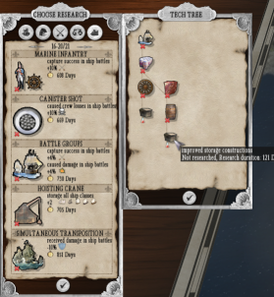Technologies are separated in 5 technology groups. You can research production technologies, new buildings, logistics improvements, new weapons, navy tactics and units.
To research LMC on the test glass in the technology short overview on the bottom left of the screen. Advanced technologies need one or more pre-technologies to be researched first which is shown by moving the cursor over the technology picture. If you click on the technology picture of an advanced technology you can take a look on the technology tree which shows all the necessary pre-technologies.
You can improve the speed of research by constructing or upgrading educational buildings in your cities.

Policies

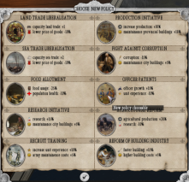Policies are used to navigate your nation into a special direction. They can be set in the policy short overview on the bottom left of the screen.
Every policy has a special advantage and a certain disadvantage which accelerates the development of your nation in one direction but slows in another direction.
Once a policy is chosen it can only be changed or cancelled by a new petition about 3 months later.

Diplomacy

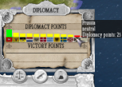The diplomacy menu can be shown by clicking on a foreign flag in the diplomacy short overview on the bottom left of the screen. Green flag borders mark allies, white neutrals and red enemies. The same colors can be shown on the campaign map borders (blue borders are own provinces).
Diplomacy works by buying or selling means through diplomacy points (in peacetime) or victory points (in wartime). You can switch the "trade" direction by LMC on the red/green arrow. The higher the available points are the more actions can be set. Good relations are shown green while bad relations are marked red. Points at or below zero means diplomatic relations are exhausted and war is declared.
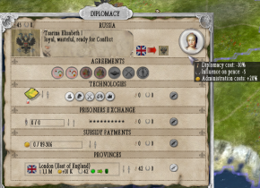Diplomacy points can also be earned or spent through the more of 30 embedded historical events where you can choose to go the historical or the alternative way.
Every diplomatic action has also some impact on nearby allies or enemies. Diplomatic actions include: technology exchange, prisoner exchange, subsidy payments and province exchanges. You can also negotiate or cancel one or two sided trade agreements, way rights or joint military actions.
Joint military actions can only be chosen with allied nations: therefore LMC on the campaign map. If the meeting point is near allied positions your ally will move troops into this range which costs diplomacy points depending on the duration of the action.
Hint: If you plan a double diplomatic exchange (e.g. offered and received trade treaty) be sure to first offer the treaty (receive diplomacy points) before you claim the treaty (spend diplomacy points) as certain actions need a minimum diplomacy point level and you lose points through “bid/ask” spreads.

Seasons

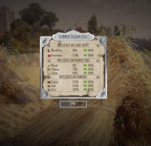Winter months range from early December to late March. During this winter season military operations should be cancelled if possible as desertion rates are rising while divisions are moving.
Furthermore production and demand is affected. Agricultural production is limited and the demand for some products like furs and coal rises.
One Russian scenario has the goal to overwinter a large troop contingent in East Prussia, so these troops have to be placed there until the start of the winter season.

Battles

Historical battles

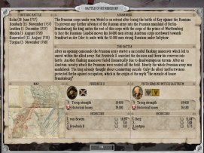You can play historical battles by selecting the historical battles section in main menu. Huge historic battles put the player in place of the great generals: The battles of Kolin, Rossbach, Leuthen, Minden, Kunersdorf and Torgau have been created based on historic terrain and army setup.
In the battle selection menu you have a brief overview about the history, involved parties and casualties.
Each battle can be played on both sides. By clicking on the check button you can start playing with the specific faction.

Campaign battles

When selecting divisions in campaign mode you can see an action radius. The range of the radius is defined by the type of troops contained. Simple Cavalry divisions are very fast and have a wide action radius which makes it favorable to cut enemy supply lines.
If the action radius of two hostile divisions is overlapping a battle starts. This battle can be solved automatically or played in a zoomed in mode. There you can move your divisions by using the advantages and disadvantages of the terrain and occupy strategic goals like cities, bridges, hills and buildings.
Every strategic goal adds to your moral as well as suffered enemy casualties. The battle is won if the enemy morale cracks. The victory conditions bar on top of the screen shows the relation between the two opponents in terms of morale and occupied goals (blue shows friendly, red shows enemy).

Selecting and moving units

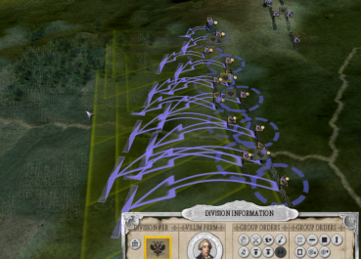Select single regiments by LMC on the regiment or select whole brigades and divisions by clicking on the brigade (silver border) and division flags (golden border). You can move your chosen single regiments by RMC on the map (hold and move RMC to define a path) or whole brigades or divisions by choosing the brigade or division symbol and RMC on the map (every RMC defines a new waypoint for each included regiment).
The orientation can be set by holding RMC (on the final destination point) and turning around. If you wish to turn a single regiment just hold the RMC over the regiment and move mouse around to set the orientation.
To clear existing waypoints simply give a stop order.
To gain a better overview of the attached units of a brigade or division you can click on the hierarchy button of the selected body. Now the whole division hierarchy opens and you can choose every single regiment by LMC on the unit icon.

Regiment information

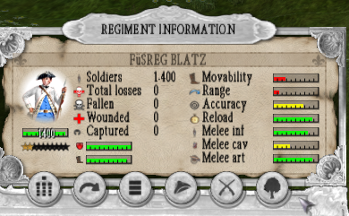If a single regiment is selected you can see the regiment information bottom left. The filled up stars represent the experience of the unit, the scale next to the heart symbol the current moral, the scale next to the boots the fatigue of the unit. The height of moral depends on the experience of the unit and the commanders. It is reduced through shock effects in battle, e.g. if an enemy volley hits the unit, especially if it is outflanked.
Clicking on the buttons below add detailed information about the unit.
1
2
3
4
5
6

- Hierarchy menu: choose other units in the brigade or division
- Order menu:
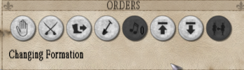
A
B
C
D
E
F
G
H

- Cancel all orders
- Cease fire: units will not fire on enemy units, RMC on enemy units now will force the chosen unit to engage in close combat
- Fast march: if activated units will move faster at the cost of fatigue and moral, you can also achieve this option by double click on the campaign map
- Build barricades: unit will start to build barricades which takes some time. Barricades increase the defense values of the chosen unit.
- Play fife and drum music: some units have the ability to play fife and drum music which increases the moral of nearby friendly units and has a negative impact on nearby enemy units. Use this when advancing towards the enemy as the moral effect is linked to the distance to the enemy units.
- Advance: unit will slowly move forward by keeping the ability to fire
- Pull back: unit will slowly pull back by keeping the ability to fire
- Regroup regiment: If a unit was split due to taking over enemy artillery you may combine it by clicking this button.
If order delay is activated, new orders will take a few minutes to be executed, depending on the distance to the brigade and division commander. If unpredictable behavior is activated, low morale units will behave irrational depending on the commander's experience. They will attack in moments when it is too dangerous or retreat even before the enemy attack reaches the line. If enemy units are close by the regimental officer takes over commander which reduces order delay but leads to an increase of unpredictable behavior.
If an enemy artillery crew was routed the artillery can be occupied by choosing an own unit and RMC on the left battery. The old regiment is then split in two
- Formation menu:
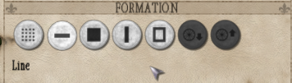
A
B
C
D
E
F
G

- Skirmish: higher distance within the line leads to lower losses through fireweapons but increases losses in close combat and against cavalry
- Line: standard formation which maximizes the number of men who may fire, high losses in close combat and against cavalry
- Column: less number of men may fire but higher strength in close combat
- March column: allows faster movement, high losses against enemy range fire and in close combat
- Square: suitable against cavalry attacks, allows firing in every direction, higher losses against enemy range fire
- Unlimber: artillery units prepare to fire
- Limber: artillery units prepare to move

- Commander information:

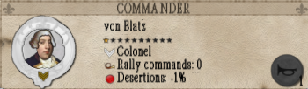Depending on the experience of the commander a certain amount of rally orders is available. If regiments have low moral or are routed you can click on the rally button to regroup and add moral. You may only do this on a regimental level. The rally orders of brigade and division commanders add to the regimental rally orders. If a division commander e.g. has 1 rally order then every regiment in this division may rally once more.

- Weapon information:
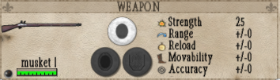In the weapons menu you can see the current level of ammunition of the selected unit and data about the used weapon. Heavier weapons may have higher range and strength but lead to lower movability. You may change the ammunition type when an artillery unit is selected, then you can choose between plain ammo (high range), shrapnel (medium range, higher losses), canister shot (low range, very high losses).

- Terrain information:
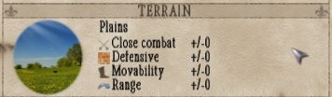Terrain has impact on the combat behavior of your unit. It may change close combat, defensive, movability and range values. If units (especially artillery) is placed on a hill the fire range and visibility increases. If obstacles limit the fire range the range marks are colored yellow or red.

Fog of war

If fog of war is activated your units can only spot and fire at enemy units in their view radius, so place your regiments on top of hills to increase the viewport or use cavalry units to scout the terrain or occupy hills in front. Especially artillery units have a higher fire than spot range. Cities, forest and fields cover units until the enemy is close by.

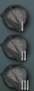Viewports

On the left side of the screen you can save and load your current viewport. If you want to separate your front into 3 sections, e.g. left, center and right you can save this perspective towards the enemy via these buttons so that you can very fast jump over to the next front section.

Reinforcements

When playing in campaign mode reinforcements may arrive on the battlefield. This happens if friendly divisions are close to the battlefield. The distance to the battlefield determines the arrival time of the reinforcements. You can see arriving units (friendly and enemy) on top of the screen during battle. In some cases the battle may already be won or lost before reinforcements arrive.
If you wish to exclude available reinforcements from a battle, for example to reserve moral, you can deactivate the check button next to the division on the battle starting screen before the battle.

End of battles

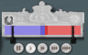A battle ends if the moral of one opponent cracks. You can view the moral relation on the victory applet on top of the screen. If the blue color exceeds the mark you have gained a major victory. If the red color exceeds the mark you have suffered a major defeat. Battles also end if the night comes, then the faction with the highest moral wins (minor victory or defeat).
A major defeat causes all the involved regiments to suffer a severe moral decline, a minor defeat only a small moral decline. All involved divisions retreat on the campaign map. If a retreat is cancelled (stop order) the division may fight again but only if enough average moral is available.
Take into account that all participating divisions should start with high moral as this increases the chances of victory. Do not move into battle with already demoralized troops.
Depending on the outcome the player earns or loses victory points which can then be used for diplomatic actions and peace negotiations.

Battle results

After or during the battle (by clicking on the victory applet) you can view the battle result. The two opponents are separated into two tables where you can see (from left to right) the current strength of the army, the strength at the beginning of the battle, the participated regiments, total losses, total losses in percent, deads, wounded and prisoners. If you click at the flag symbols you may see only the losses of the chosen faction (if allies joined the battle).
Prisoners can be taken if a routed unit was engaged in a melee. So it may be a good opportunity to chase enemy routed units with your cavalry to make prisoners for exchanging them afterwards.
Wounded soldiers may come back to action again, they recover depending on the health situation of the current province.
The hearts on top of the menu indicate the final average moral of the both armies. The number left to the silver laurel wreath show the resulting victory points, the position of the laurel wreath indicate the winner of the battle. The earned or lost victory points result of the number of enemy casualties in relation to the own casualties and a bonus for the victory and an extra bonus if you have gained a major victory.

Options menu

25
24
23
22
21
20
19
18
17
16
15
14
13
12
11
10
9
8
7
6
5
4
3
2
1
- Click on the screen resolution to change. Shown are the available resolutions, I recommend only to use white resolutions and skip the red marked ones for better readability.
- Change graphics device if you have an onboard second graphics card with more vram.
- Windowed mode can be used to run the game not in fullscreen mode which opens the possibility to alt-tab during game without loss of graphics. Therefore I recommend you to use a bit lower screen resolution than your desktop resolution as the borders may disappear due to the windows taskbar.
- Detail textures may lead to lower FPS, deactivate if game runs too slow.
- Vegetation details may lead to lower FPS, deactivate if game runs too slow.
- Fogs may lead to lower FPS, deactivate if game runs too slow.
- Mouseover-information ingame can be deactivated, I recommend you not to do this.
- Detail textures may lead to lower FPS, deactivate if game runs too slow.
- Reduce number of trees if the game runs too slow.
- Vegetation details may lead to lower FPS, reduce if game runs too slow.
- Increase battle unit updates for smoother movement (this leads to lower game speed/FPS). If battles run too slow and you do not want to reduce the number of sprites try to reduce this option although units may jump then.
- Adjust the number of sprites in battles. Keep in mind that there can be 500 regiments per battle with a maximum of 300 sprites per regiment – increasing this may lead to a slow battle performance.
- Activate unit symbols to show troop types (infantry, cavalry, artillery) during battle.
- Activate enlighten menus if you have trouble reading the font and want to increase contrast.
- Sound and music volume can be adjusted for campaign and battle.
- Click on the language to change the ingame language.
- Activate uncoordinated orders to increase realism: your officers may execute wrong or own orders (e.g. attack if the enemy is too strong, or retreat even before an enemy assault has reached your lines).
- Activate order delays to increase realism: your commanders execute your orders only delayed, depending on the distance to their brigade and division commanders. The closer all divisional units are situated the faster the orders are executed. On close range to the enemy the regimental commander takes over control which may lead to a higher rate of uncoordinated orders.
- Activate fog of war to hide enemy units out of sight. Allies are discovered.
- Activate fog of war to hide enemy units out of sight.
- Adjust scroll speed for campaign map.
- Adjust scroll speed for battle map.
- Click on the rhythm to change autosave period. The game may hold for a second while saving.
- Deactivate battle time limit if you like to fight till the end without coming to an earlier end due to nighttime (results in no minor victory/defeat).
- Click on the hotkey to input a new key for the stated action. Hotkeys are only shown for keyboards in the used game language. So if you are playing the game with any other system language you may see another key, although it works with the pressed key.

